OSINT and Reconnaissance Lab Report

1. Introduction
This lab focuses on Open Source Intelligence (OSINT) techniques using tools such as Recon-ng, Maltego, and Shodan. The objective is to enumerate subdomains and identify exposed services of a target domain using passive reconnaissance methods.

2. Tools Used
- Recon-ng
- Maltego
- Shodan
- Kali Linux

3. Subdomain Enumeration using Recon-ng
The Recon-ng tool was used to enumerate subdomains using the HackerTarget module.

Commands Used

modules load recon/domains-hosts/hackertarget
options set SOURCE tesla.com
run
show hosts

Results
Subdomain | IP Address
example.com | 104.20.23.154
www.example.com | 104.18.27.120

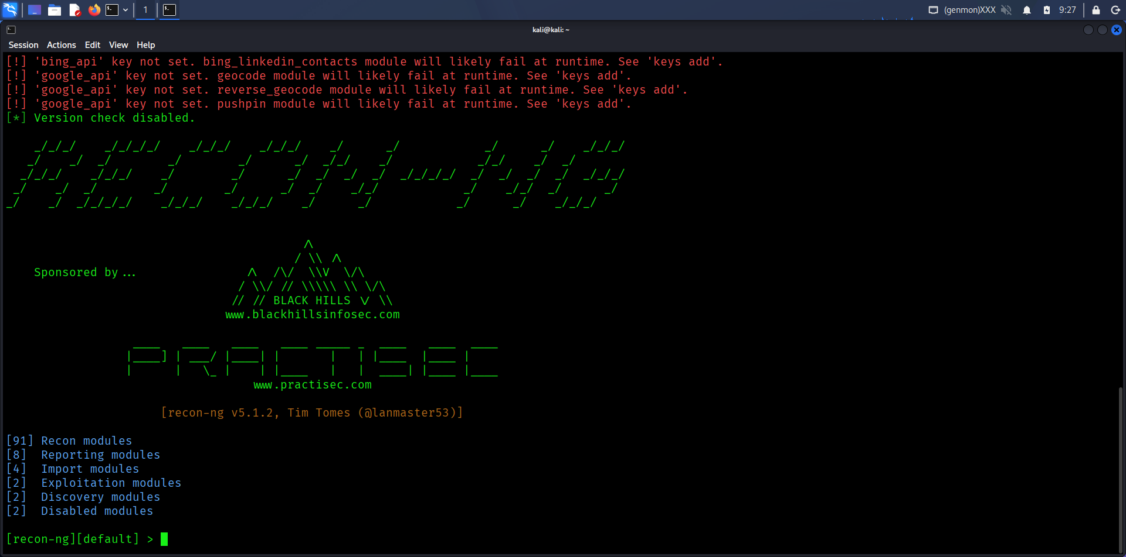

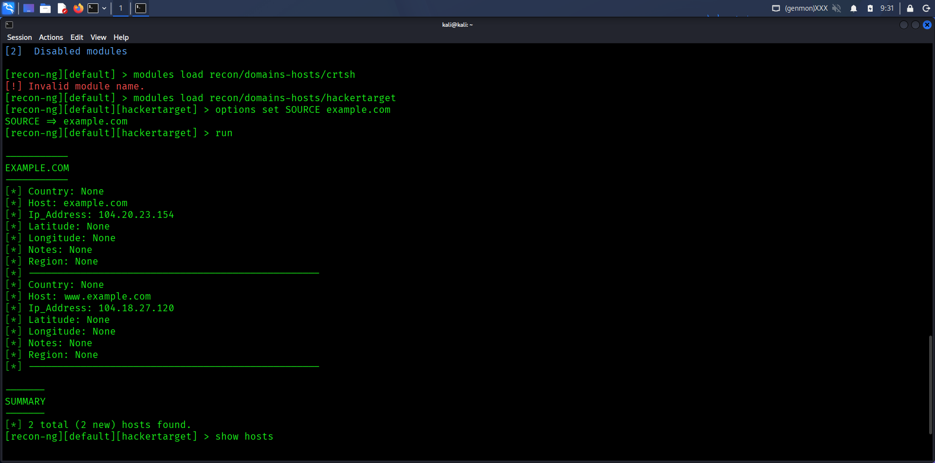

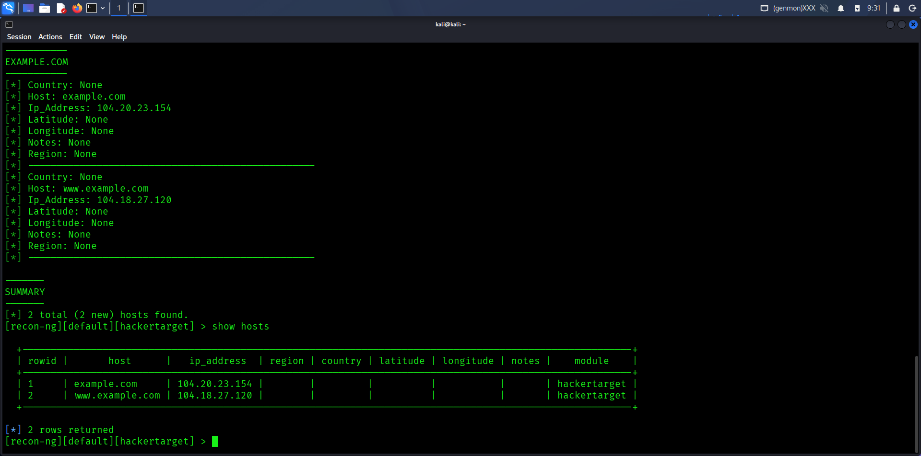

4. Shodan Analysis
Using Shodan, exposed Apache servers were searched using:
apache country:US

Summary (50 words)
Shodan search for Apache servers in the US reveals exposed hosts running outdated versions with open HTTP ports. Some systems expose directory listings and misconfigured services. These hosts may be vulnerable to known exploits, highlighting the importance of patching, firewall restrictions, and minimizing public-facing services.

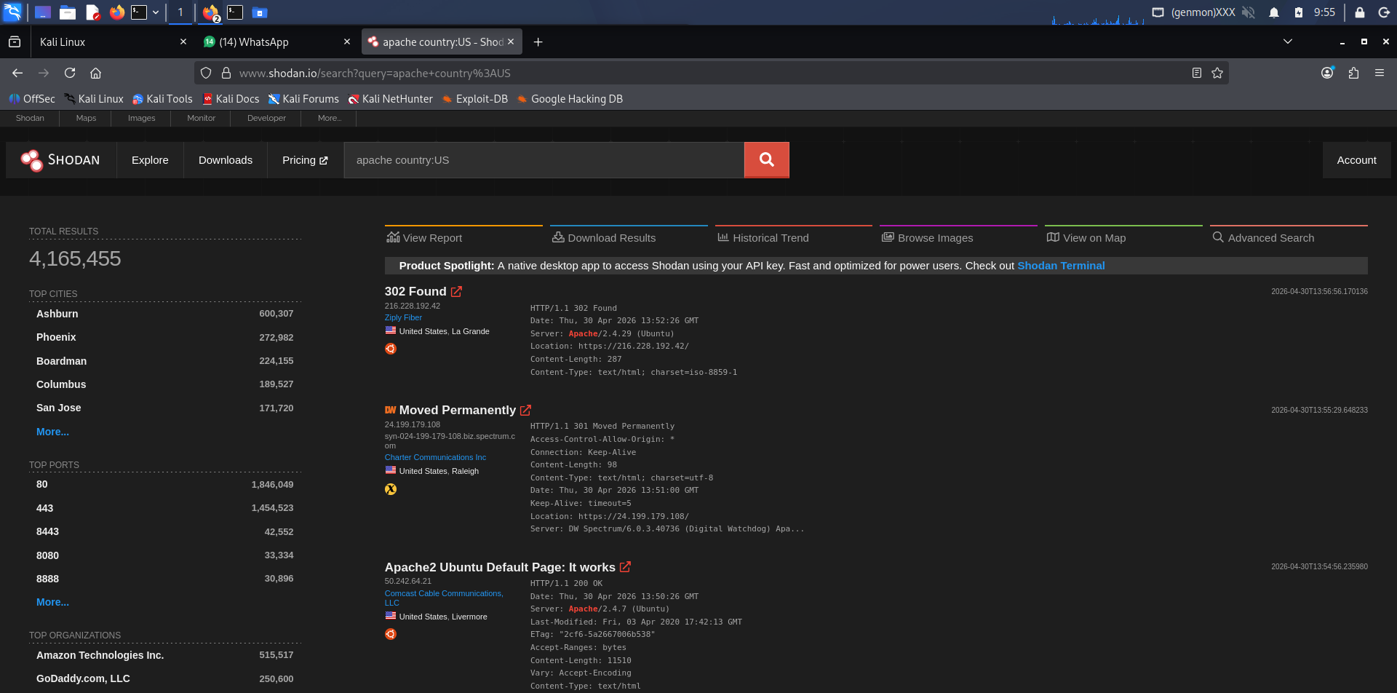

5. Conclusion
This lab demonstrated how OSINT tools can be used to gather information about a target without direct interaction. Recon-ng provided structured data, Maltego visualized relationships, and Shodan revealed exposed services, highlighting potential security risks.

